**CLIENT MANAGEMENT SYSTEM**

**USING MYSQL**

Name: P. Sahithi

Batch No: BH09

Project Name: Client Management Database System.

**SQL (Structured Query Language),** which stands for Structured Query Language, is a domain-specific language used for managing and manipulating relational databases. SQL is used to perform operations on the records stored in the database, such as updating records, inserting records, deleting records, creating and modifying database tables, views, etc.

**MySQL** is an open-source relational database management system (RDBMS) that uses SQL as its query language. It is one of the most popular and widely used RDBMSs in the world. MySQL is known for its speed, reliability, and ease of use.

MySQL follows the working of **Client-Server Architecture.** This model is designed for the end-users called clients to access the resources from a central computer known as a server using network services. Here, the clients make requests through a graphical user interface (GUI), and the server will give the desired output as soon as the instructions are matched. The process of MySQL environment is the same as the client-server model.

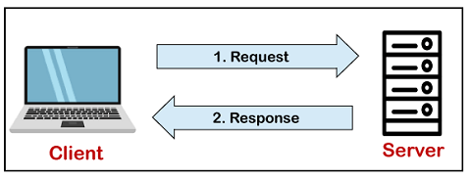

**You have been assigning to create a database of client management database system that should store information about company, services provided by the company, client details, professionals who involved, invoice.**

**ER Diagram**

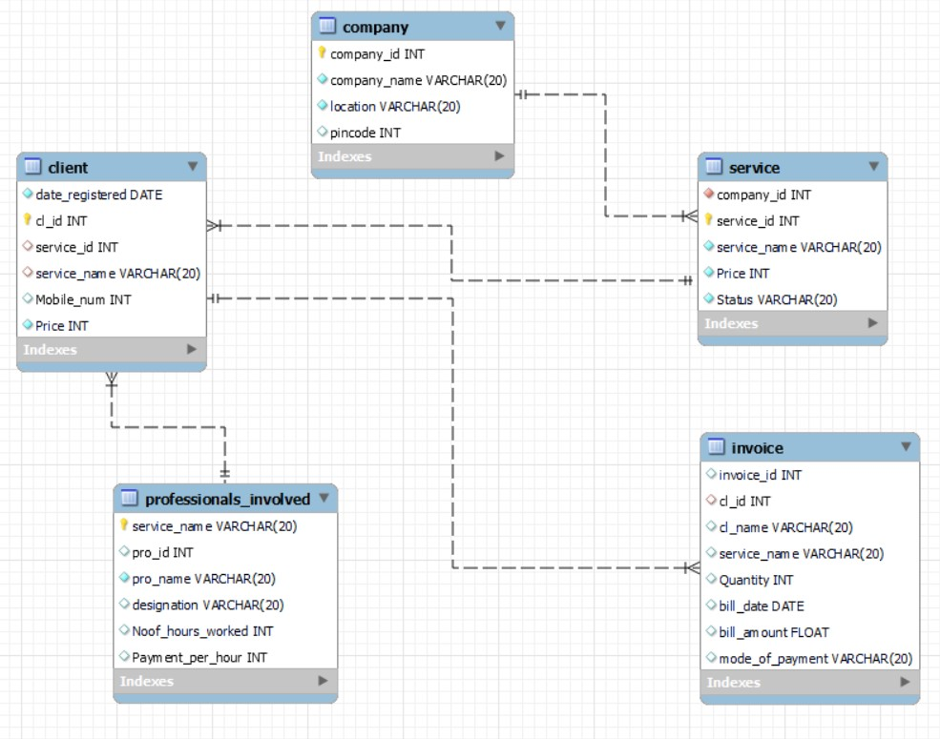

**Design the database scheme answer the following questions.**

**Steps:**

* Open MySQL and Create a Database with database name called “Client Management

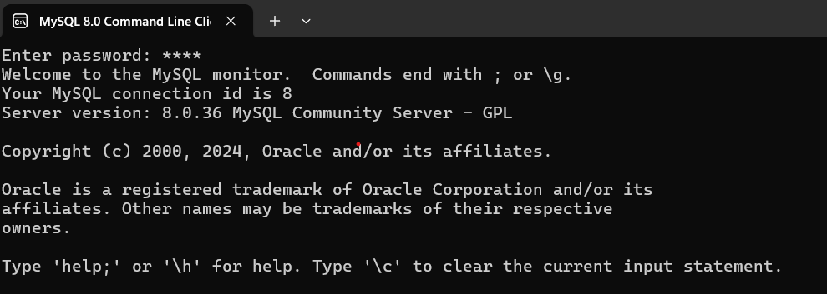



* Show Databases

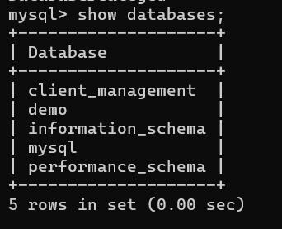

* Use database



* Create tables of Company, Service, Client, Professionals_involves, invoices.

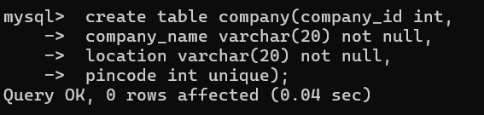

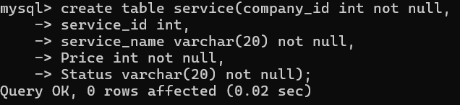

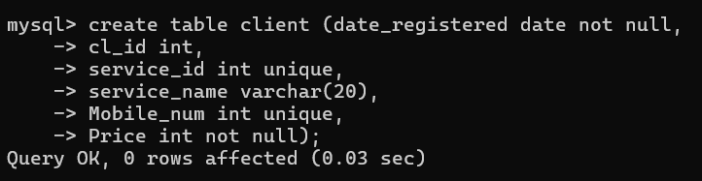

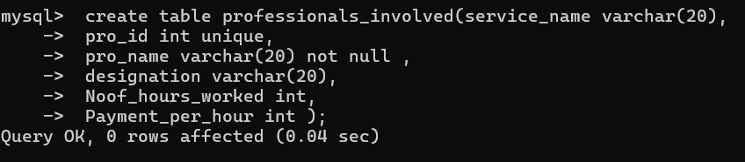

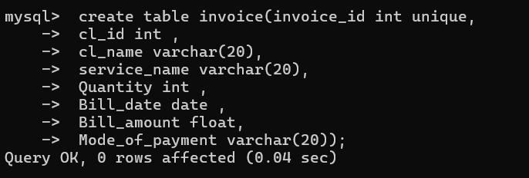

* Adding Primary key

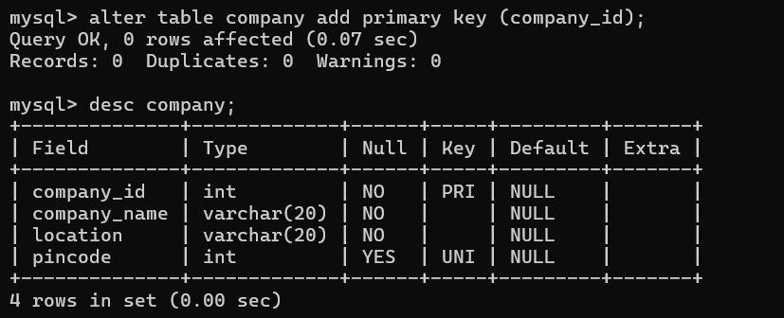

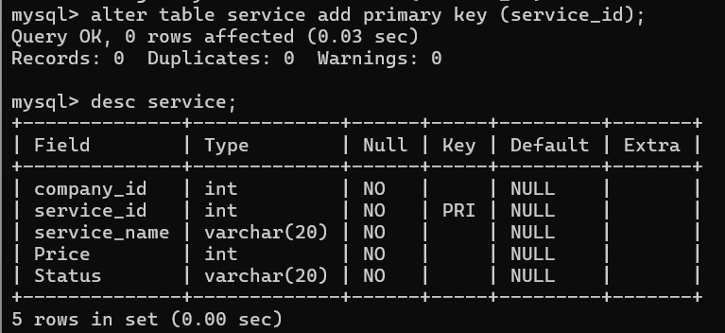

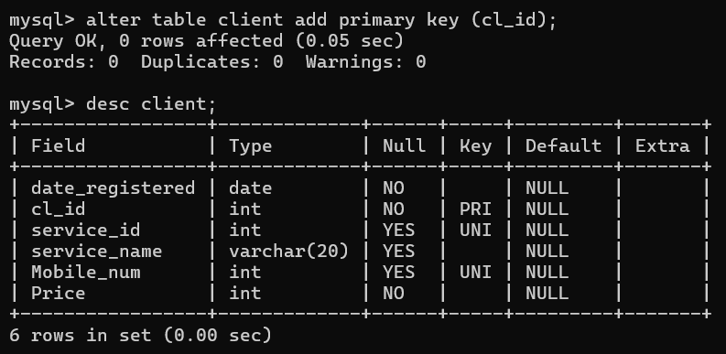



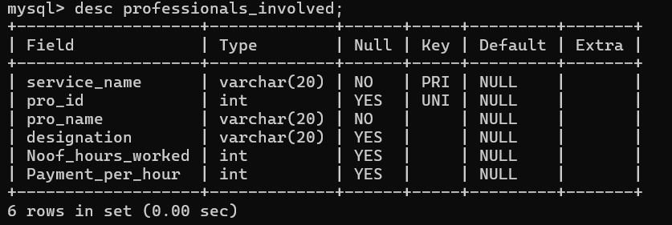

* Insert Data into Tables



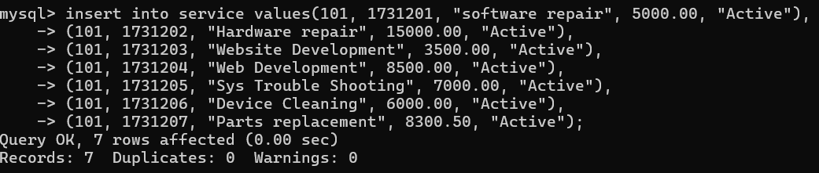

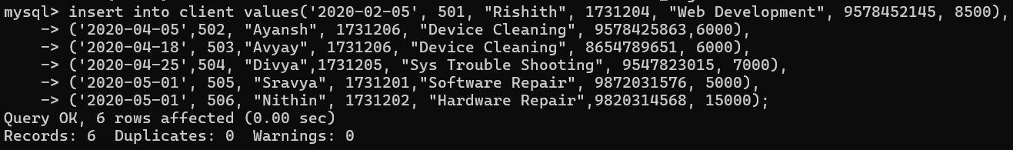

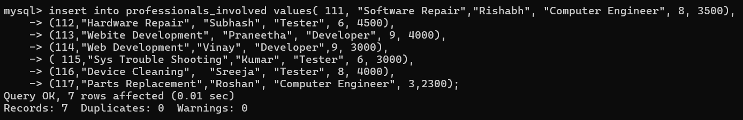

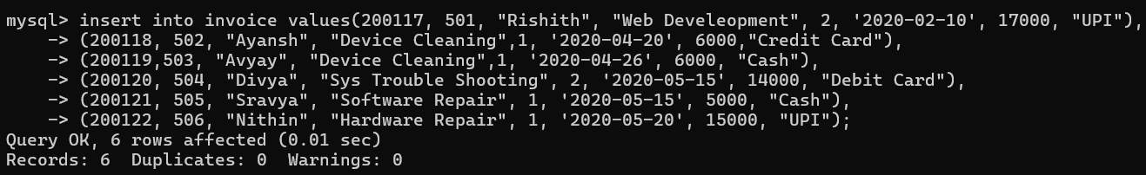

* Retrieving data using SELECT command.

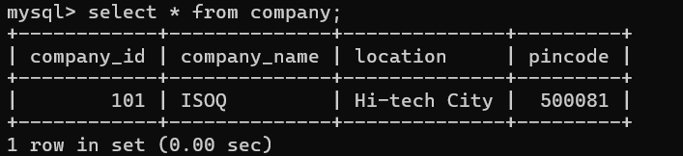

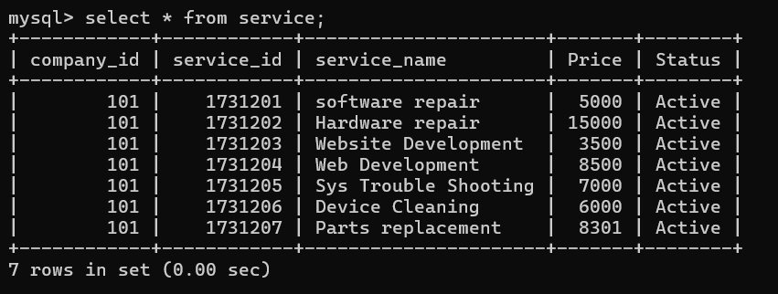

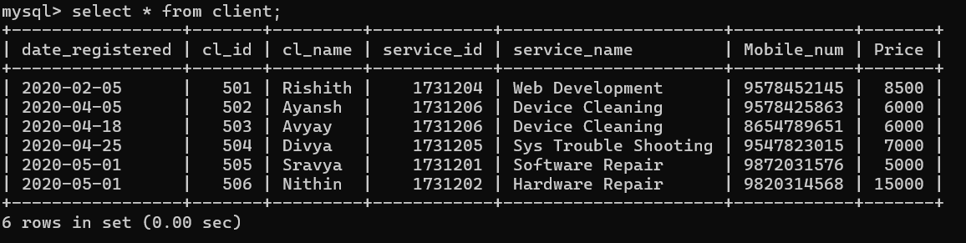

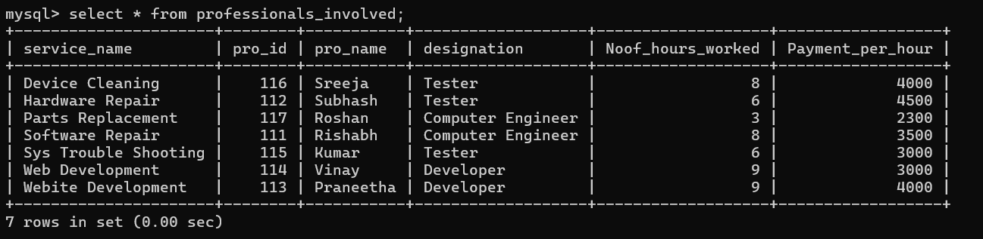

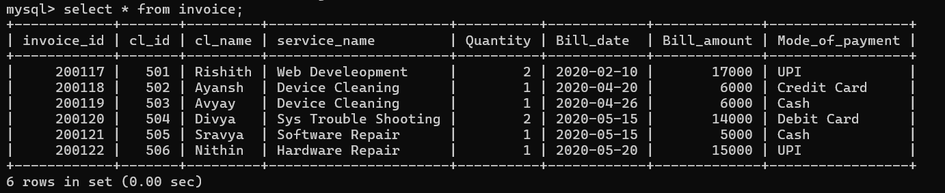

* Delete command:

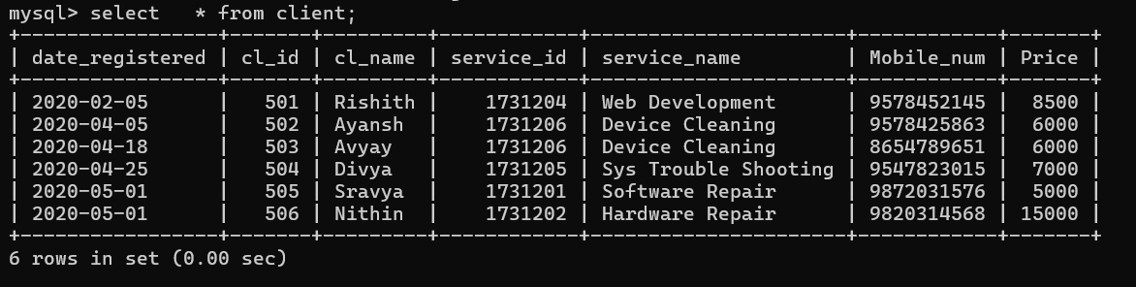

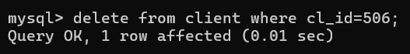

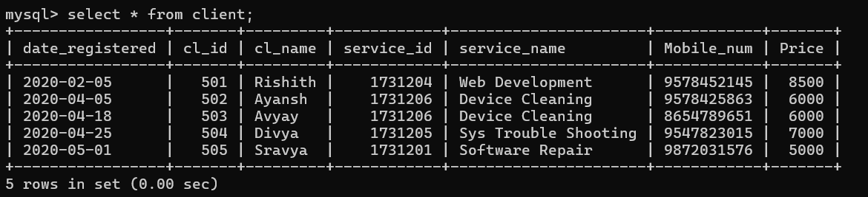

* Adding Foreign Key

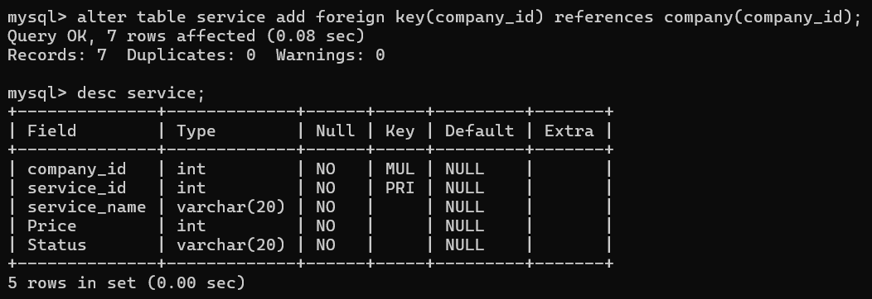





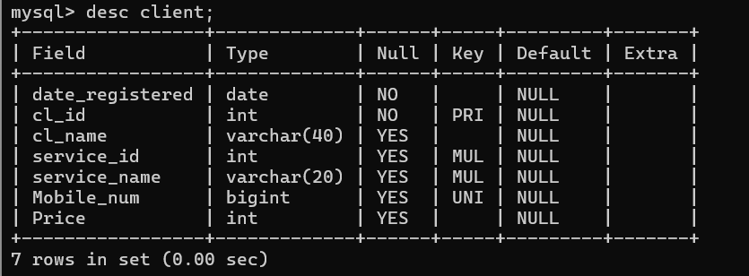

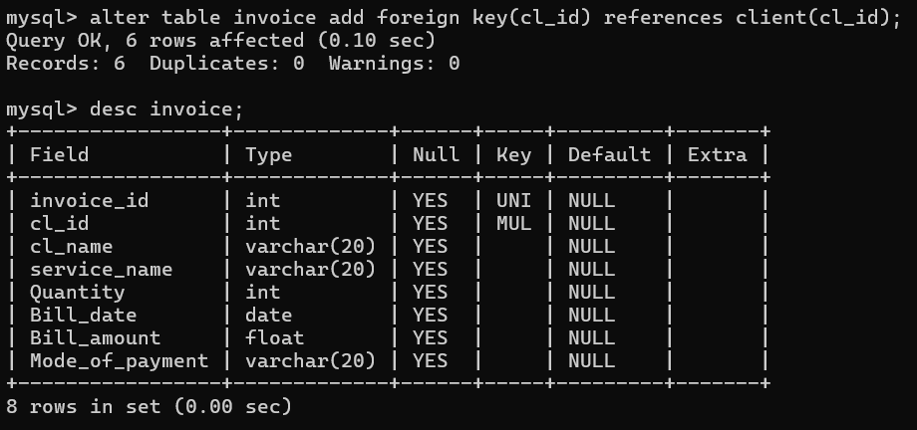

* Operators

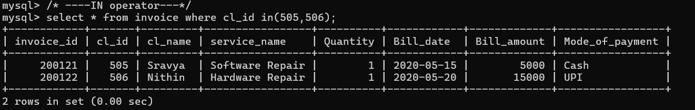

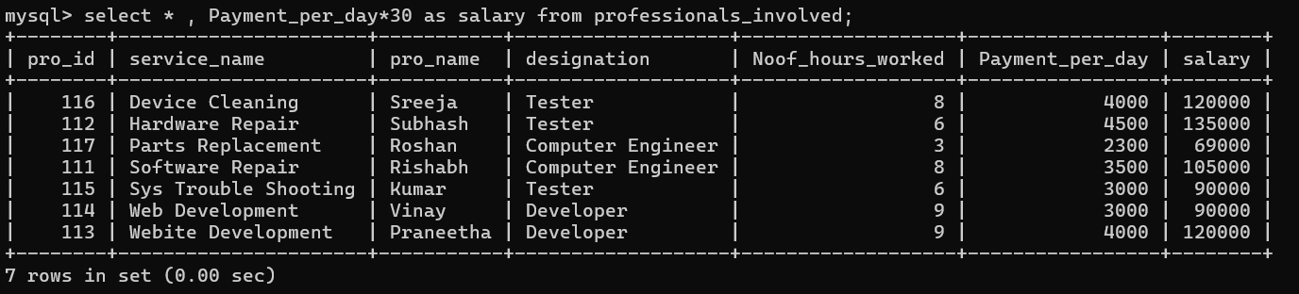

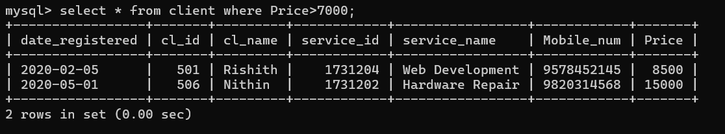

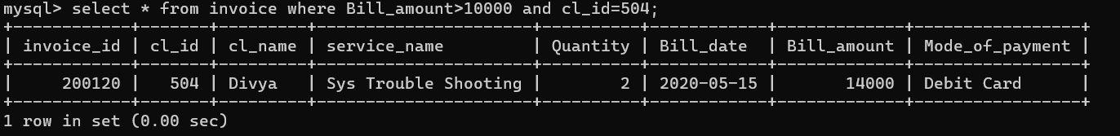

* LIKE operator:

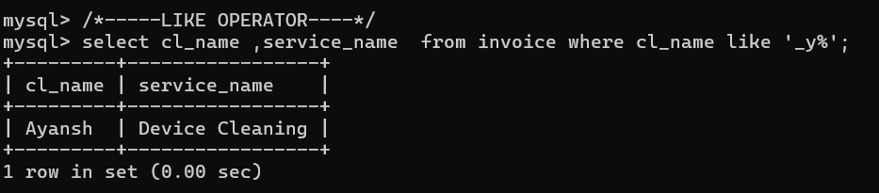

* BETWEEN Operator

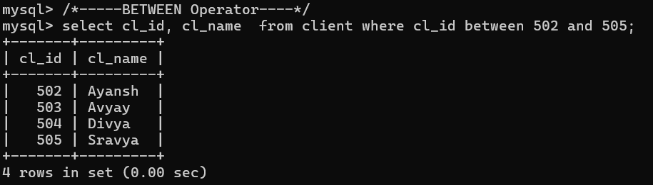

* IN Operator



* Create View



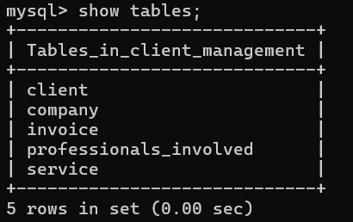 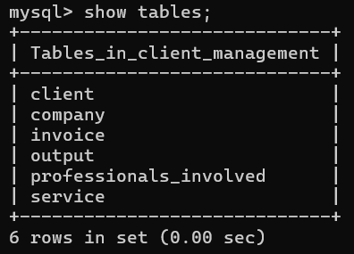

* Aggregate Functions

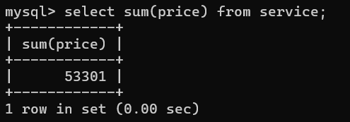

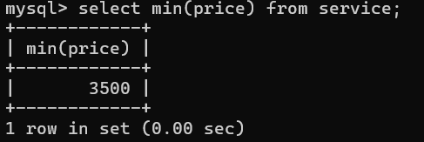

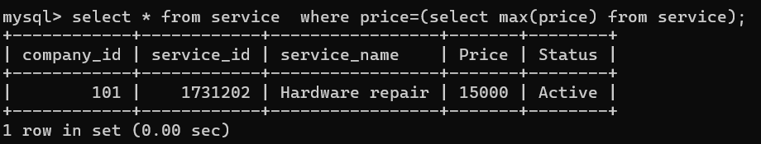

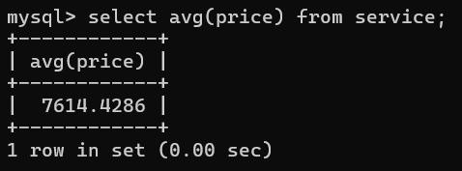

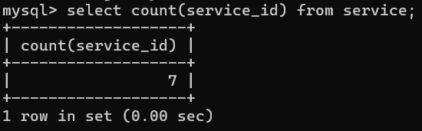

* Cross join

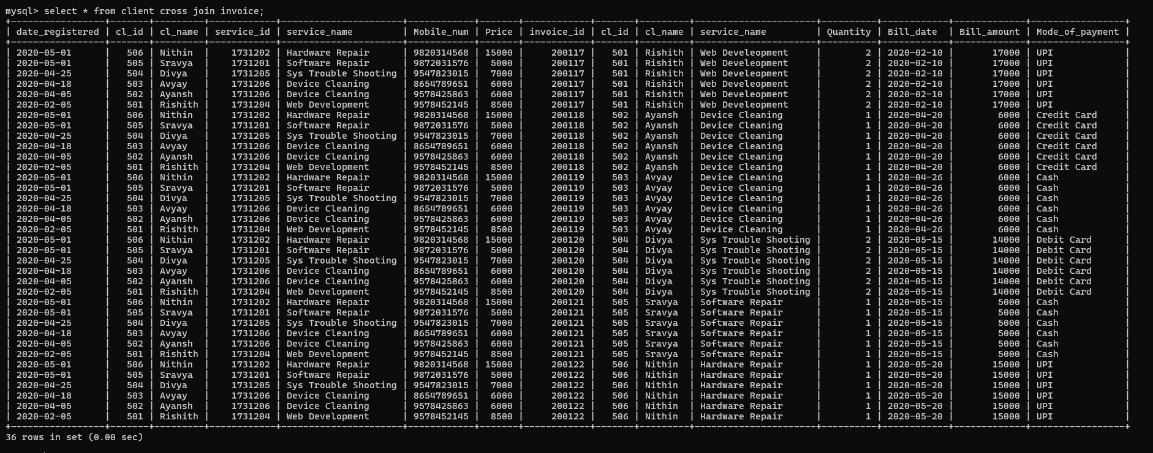

* Inner join

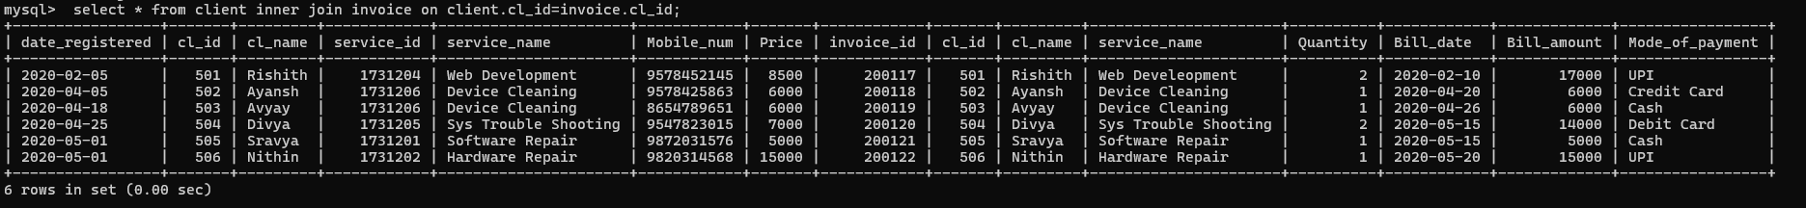

----------------------------- \**THANK YOU*\*-------------------------------------------